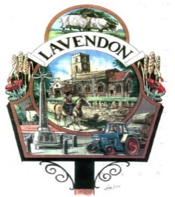
LAVENDON PARISH COUNCIL

The Code of Conduct for Councillors and Co-Opted Councillors

You are a member or co-opted member of Lavendon Parish Council and hence you shall have regard to the following principles - selflessness, integrity, objectivity, accountability, openness, honesty and leadership.

You must promote and support high standards of conduct when serving in your public post, in particular as characterised by the following requirements, by leadership and example.

Accordingly, when acting in your capacity as a member or co-opted member:

1. You must act solely in the public interest and should never improperly confer an advantage or disadvantage on any person or act to gain financial or other material benefits for yourself, your family, a friend or close associate.
2. You must not place yourself under a financial or other obligation to outside individuals or organisations that might seek to influence you in the performance of your official duties.
3. When carrying out your public duties you must make all choices, such as making public appointments, awarding contracts or recommending individuals for rewards or benefits, on merit.
4. You are accountable for your decisions to the public and you must co-operate fully with whatever scrutiny is appropriate to your office.
5. You must be as open as possible about your decisions and actions and the decisions and actions of your authority and should be prepared to give reasons for those decisions and actions.
6. You must declare any private interests, both pecuniary and non-pecuniary, that relate to your public duties, and must take steps to resolve any conflicts arising in a way that protects the public interest, including registering and declaring interests in a manner conforming with the procedures set out below.
7. You must, when using or authorising the use by others of the resources of your authority, ensure that such resources are not used improperly for political purposes (including party political purposes) and you must have regard to any applicable Local Authority Code of Publicity made under the Local Government Act 1986.

Adopted by Lavendon Parish Council at the council meeting dated 11th September 2023

